When and where

Opening session: Sunday 7th January 4 – 5.30pm
at breathing space coventry, 123b Birmingham Road, CV5 9GR

You will meet other participants, the prayer guides, and be
introduced to the retreat, its prayer approaches, and meet
with your prayer guide of the following 6 weeks.

Closing session: Sunday 18th February 4 – 5.30pm
at breathing space coventry, 123b Birmingham Road, CV5 9GR

To book a place, please provide the following to Lois :

Email: breathingspacecoventry@gmail.com
OR
Phone: 02476 713381

Name
Postcode
Mobile:
Email:

For my weekly meeting with a prayer guide, I prefer –
Daytime only/ Evening only / Either day or evening

I am available these days of the week:
Mon / Tues / Wed / Thurs / Friday

….before 2018 gets away on me
….while I keep on with everyday life
…. deepening my awareness of God and self

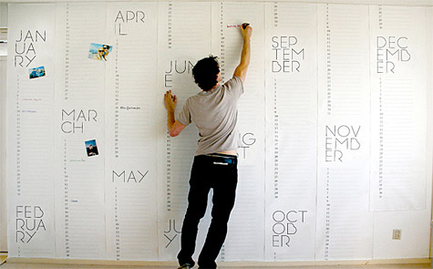

a New Year retreat in daily life

January – February 2018

What is it?
Over six weeks we set aside time to retreat, not away from our normal life but in it – taking time to pay attention, to pray and to reflect.
Most people aren't able to spend time away from work in a secluded and peaceful retreat centre to pursue their relationship with God (great as that might be).
So here is an opportunity to commit to more intentional prayer while continuing normal routines.
Why do it?
- We are growing and changing.
Sometimes we outgrow the patterns of prayer that have suited us well in the past. This type of retreat gives space to explore new ways of prayer that fit our current situation in life.
- We are busy.
Work, family, friends, occupy so much of our time and attention. We may have an uneasy sense that we've sidelined our relationship with God. Taking time to focus attentively on that relationship can help us discover God waiting with open arms to welcome us home.
- Life happens.
Good things, sad things, perplexing things. Sometimes we just have to stuff them in a cupboard for later. With the support of your prayer guide over these weeks, you may choose to open the cupboard door and look at some of the 'stuff' with God.
- God invites us.
'Come away with me to a quiet place and rest for a while,' says Jesus to his disciples. (Mark 6:31). On another occasion he asks, 'What do you want me to do for you?' (Mark 10:51).

How does it work?

- Gathering as a group of pilgrims and prayer guides, to get ourselves started – on a Sunday at 4pm.
- Spending half an hour privately each day reflecting on a Bible passage or with other prayer material;
- Spending 30-40 minutes once a week with your prayer guide reflecting on what happens in your prayer; You choose the time and place of your private prayer, and negotiate a time and place to meet your prayer guide.
- Gathering together again, as individuals and as a praying community, to draw the ‘retreat’ to a close.

For God alone my soul waits in silence Psalm 62.6

What's a prayer guide?
A prayer guide is trained in the art of listening with another to the Spirit's direction. Your prayer guide will listen to you and listen with you as you reflect on what happens (or doesn't happen) in your prayer and life each day. She or he may suggest Scripture passages for meditation, or tell you about an approach to prayer you might like to explore. Your relationship with God is the focus, and anything from your faith, and life situation, is therefore relevant. A prayer guide is not a counsellor, but like counsellors they hold whatever they hear in confidence. Prayer guides are also supervised in their work.

In these weeks you are invited to listen to your life.

“There is no chance thing through which God cannot speak … and the words God speaks are incarnate in the flesh and blood of ourselves and of our own footsore and sacred journeys. …Listen for God. Listen to the sweet and bitter airs of your present and your past for the sound of God.”
(Frederick Buechner)

