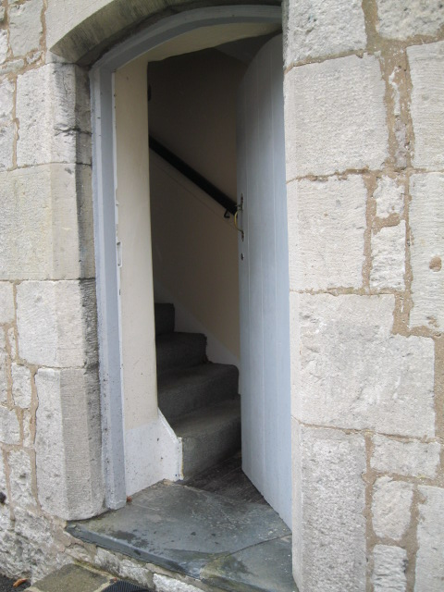

second chances

second chances
a rhythm of prayer incorporating Servants’ principles and values

This series of ten liturgies for group or personal use is based on the story of Ruth and five encounters with Jesus recorded in the early chapters of the Gospel of John.
They are paired around the themes of … seeking … returning … risking …encounter … redeeming
One of Servants’ five principles and five values is integrated into each prayer sequence, thus:

1 Seeking Ruth 1a Wholism
2 Seeking John 1 Simplicity
3 Returning Ruth 1b Beauty
4 Returning John 4 Servanthood
5 Risking Ruth 2 Rest
6 Risking John 5 Community
7 Encounter: Ruth 3 Grace
8 Encounter John 6 Creativity
9 Redeeming Ruth 4 Incarnation
10 Redeeming John 2 Celebration

This prayer resource has been written, compiled and prayerfully crafted by Lois Baldwin
with input and encouragement from Monica Hof- McKinlay, and Peter Sidebotham.
The artwork is sourced from contemporary street artist, Banksy; from German priest, Sieger Koder; from European masterpieces; from google images; and from personal files.

January 2017

1 Seeking ….
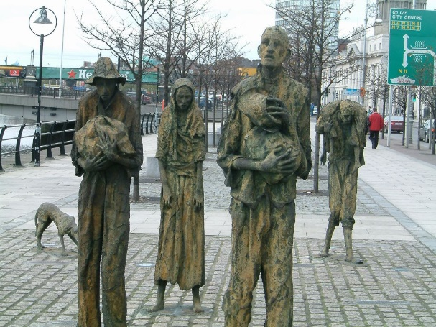

Rowan Gillespie’s sculptures in Dublin depicting migrants in the Great Potato Famine from 1845 to 1852.
WHOLISM
CALL TO PRAYER
Trust in God at all times, people
Pour out your hearts to the Holy One
For God alone my soul waits in silence
Stillness
OUR THEME
Seeking: Naomi with her family seeks a sustainable life in a new country
It is grim out there. Chaos, deceit, raw power, dire suffering, revenge, abuse, greed.
What is our world looking for?
It is grim in here. Confusion, deceit, competitiveness, control, self-indulgence, guilt.
What am I looking for?
Where is life, vitality, wholesomeness?

Companion us, Holy One, in our seeking.
Be the questions where we have answers
Be the paradox where we have certainty
Be the lyrics of our lament
Be the shadows of our searching
Be the emptiness of our loss
Companion us, Holy One, in our seeking.

SCRIPTURE Ruth 1:1 – 6
1 Samuel 1:1-8 Psalm 27.4 Songs 5.2-8 Luke 8.42b-48 Romans 8.19-26
REFLECTION
Let’s inhabit the narrative for a moment: The land under stress … the changes in weather patterns … relentless dry winds … or was it constant rain? … the crop fails … the months pass … the famine sets in … the famine.. sets … in.
Hard choices … four of us … a chance in Moab … with strangers, different, outsiders, no! … hunger gnaws … we have to go, there’s a chance … loss of community, but there’s life … or is there? … Ten long years … loss of loved ones, loss of a future … longings, loss of significance … seeking a second chance …

Silence – extended

Respond
+ brainstorm the causes of migration, and famine, and family disintegration
+ write a lament for a situation you know
+ as a group, mime the narrative while it is read slowly
+ spend some time in a garden: walking, sitting, pulling weeds… engage with the cycles of life and decay, savour the goodness, the soil, the plants.
+ sit with the following prayer -

A Mother in Poverty
O Lord listen to my cry. I am in a deep hole of suffering.
When I sleep, hoping for a better tomorrow,
the sun rises with more problems at my face.
Very sick children. Empty cups without drinks in them. No plates of food to eat.
I pray every time, thinking that God will provide,
But nothing changes.
Jesus, come and help me overcome this poverty
In Jesus’ name I pray. Amen ~ Sr Vicky Waraka, Mundri, Sudan.

PRAYER FOR OURSELVES, OTHERS AND OUR WORLD
We want to see the good news of Jesus proclaimed in word, deed and power. We have a God who is working to renew all things and to restore wholeness of life to all creation. Our lives amongst the poor call us to care for individuals, families and communities, as well as for the structures and systems of human society and for the environment on which we all depend. We work for justice, proclaim God’s grace, and lift all things to God in prayer. Servants’ principle: WHOLISM

God of wholeness, we pray you may restore life to all creation … come renew our communities, our economic systems, our environmental policies, and especially today:
Open prayer
~ Banksy
Pray together

Holy Painter of sunrises, the sunrise this morning was soul inspiring
The colours, muted as though veiled by sheer angel wings,
gave birth to a smile in my heart.
Each sunrise – the advent of light, warmth, colour
Each sunset – the herald of a second chance at day.

Frail and splendid, our planet Earth.
Earth-maker, teach us how to steward its fruit.
The fruit of the Earth is air, water, soil,
plants, animals, minerals, fire, beauty, space.
Frail and splendid, our planet Earth.

Frail and splendid, each human spirit.
Holy Spirit, teach us how to grow your fruit
The fruit of the Spirit is love, joy, peace, patience,
kindness, generosity, faithfulness, gentleness, self-control.
Frail and splendid, each human spirit.
God of second chances, have mercy on us.

SONG
Within the darkest night, you kindle a fire that never dies away. (Taize chant)
(see: www.youtube.com/watch?v=8mceqqE452M )
BENEDICTION
Companion us, Holy One, in our seeking.
May we find peace in the paradoxes
May we find joy in our quests
May we find love in lament
May we find God in all things
Companion us, Holy One, in our seeking. Amen
2 Seeking …
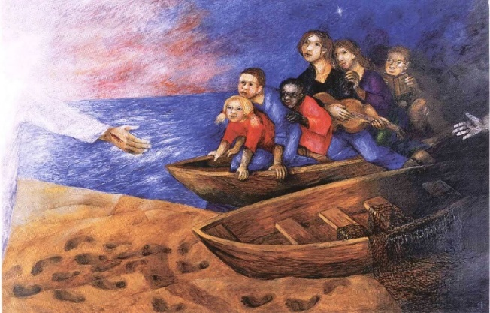

~Sieger Koder
SIMPLICITY
CALL TO PRAYER
Trust in God at all times, people
Pour out your hearts to the Holy One
For God alone my soul waits in silence

Stillness
OUR THEME TODAY
Seeking. Andrew and his friend seek a new leader to follow, a new way of being … something or someone to inspire, energise, call them on.
What am I looking for? What are we looking for?
Where is life, vitality, wholesomeness? A vision that sustains …
***

On tiptoe we stand, Lord Jesus, eagerly awaiting your full revelation,
Always expecting you to come some more.
Our hands and our hearts are open to your grace,
Our lives still waiting for the fullness of your presence.
We are those who have been promised a kingdom, and we can never forget.
Yet we have a foot in both worlds and so we stumble.
But still we stand - owning our kingdom-loving hearts and our earth-eyes.
We lean forward and hope.
M Wiederkehr, Seasons of Your Heart.
~ Banksy

SCRIPTURE : John 1:35-41
Proverbs 30.7-9 Amos 5.4-15 Mark 10.13 – 16 Rev 18. 2, 14-19
REFLECTION
….. Invite the Holy One to speak to you. Prepare your heart to listen…..
Read the passage three times slowly; allow a word or phrase, a question or action to touch you.
Reflect on this word or phrase, letting it speak to your personal situation. Notice God’s invitation, challenge, encouragement.
Respond and talk with God about what you have noticed ….
Rest quietly in the presence of the One who loves you. Let the word move gently from your head to your heart to dwell there in peace.

Silence - extended

Respond
+ Gaze at the painting by Sieger Koder. Identify with one of the boat-people – and imagine what happens next.

+ Recall when you were last with children: what might they teach you about seeking, exploring, learning? How does being child-like connect with living in God’s kingdom?

+ Choose one of the following questions, make an inventory, and use it as the basis of prayers to follow - of lament, confession, solidarity, and gratitude.
.what do the actions of my life reveal that I am seeking?
.what do the actions of people in this / my country reveal that the nation is seeking?
.what do the actions of this community or team reveal that we are seeking?

+ Talk with the Holy One about what enthuses you or about how you would like to be filled with energy for a people, a task, a situation. How might God reply? How does God reply?

PRAYER FOR OURSELVES, OTHERS AND OUR WORLD
We commit ourselves to lifestyles of inner and outward simplicity, in order to be free to love and serve God and the poor. Setting aside our ‘right’ to affluence while there are still those who live in abject poverty, we desire to be a relevant yet prophetic voice in a world preoccupied with self.
Servants’ principle SIMPLICITY

May we single-mindedly desire what You desire for our communities, families, ourselves and our world … And especially today we lament … we confess … we commit to …
Open prayer
Pray together
Dear God,
We give thanks for places of simplicity and peace.
Help us find such places within ourselves.

We give thanks for places of refuge and beauty.
Help us find such places within ourselves.

We give thanks for places of nature’s truth and freedom, joy, inspiration and renewal, places where all creatures may find acceptance and belonging.
Help us search for these places in the world, in ourselves and in others.
May we restore them.
May we strengthen and protect them and may we create them.

May we mend this outer world according to the truth of our inner life and may our souls be shaped and nourished by nature’s eternal wisdom. AMEN. (Leunig)

SONG The kingdom of God is justice and peace and joy in the Holy Spirit.
Come Lord and open in us the gates of your kingdom. (Taize)

BENEDICTION
Companion us, Holy One, in our seeking.
May we find peace in the paradoxes
May we find joy in our quests
May we find love in lament
May we find God in all things
Companion us, Holy One, in our seeking. Amen
3 Returning …
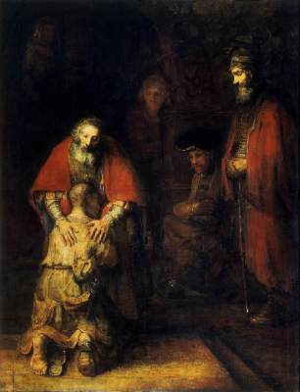

~Rembrandt, The Return of the Prodigal

BEAUTY

CALL TO PRAYER

Trust in God at all times, people
Pour out your hearts to the Holy One
For God alone my soul waits in silence

Stillness

OUR THEME TODAY

Returning. It’s a bit embarrassing, returning, with a tail between our legs .. humiliating even. We set out in full splendour, on our life ventures and projects and dreams. Like the ambitious prodigal son, like Elimelek and Naomi, like Job, like John the Baptist, Joan of Arc, Martin Luther King, like Servants workers! And our returning … muted, frail, empty … Back to another beginning – a second chance at life?

Do not hurry as you walk with grief; It does not help the journey.
Walk slowly,
pause often:
do not hurry
as you walk with grief.

Be not disturbed by memories that come unbidden.
Swiftly forgive; and let Christ speak for you unspoken words.
Unfinished conversation will be resolved in Him: be not disturbed.

Be gentle with the one who walks with grief.
If it is you, be gentle with yourself.
Swiftly forgive;
walk slowly,
pause often.
Take time, be gentle, as you walk with grief. ~ Andy Raine, “Walking with Grief”

SCRIPTURE : Ruth 1:7-22
Genesis 35.1-15 Psalm 51 Hosea 6.1-3 Luke 15:11-24

REFLECTION
She started to return … she set out … … they went on their way to go back … “Go back to your mother’s house” … “ no we will return with you” … “Turn back, my daughters” … “Turn back, my daughters, go your way” … Then they wept aloud – again … “your sister-in-law has gone back … return after your sister-in-law” …
So, much turning and returning, back and forth, to-ing and fro-ing; and then - beautiful words of loyalty and love, frailty and splendour:
“Do not press me to leave you or to turn back from following you! Where you go, I will go; where you lodge, I will lodge; your people shall be my people, and your God my God. Where you die, I will die – and there will I be buried.”
And Naomi is silenced. . . until: “I went away full but the LORD has brought me back empty” … and so Naomi and Ruth returned together … to the beginning – of the barley harvest.

Silence – extended

Respond
+ share returning empty stories
+ with a partner, create a live sculpture to express the beauty of returning together
+ read aloud Ruth’s words slowly several times and notice the phrase that speaks and resonates with you.
+ contemplate the Rembrandt painting. Notice the colours, shadows, forms, texture. Invite the image to a place deep with you. Stay with what most ‘affects’ you. Let God visit you. Let your ‘real self’ make conversation with the ‘real God’.
+ pray …
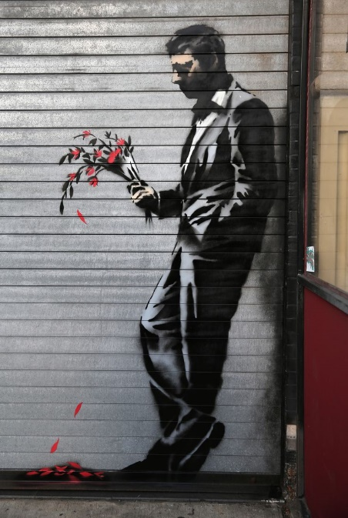
Coming back empty, o God, is not what we’re comfortable with
Running on empty – yes, that gets admired.
But empty-handed and empty-spirited looks
too much like empty-headed.
Lord, have mercy.

Emptiness, vacuum, void …
We confess, Earth-maker, Pain-bearer, Life-giver,
that we are afraid of these.
We can’t wait for fullness, for blessing, for presence.
We must have small luxuries, fleeting loves,
complex systems, steady organisations.
Christ have mercy.

Emptiness, vacuum, void …
Is that what you look for, Eternal One? Emptiness?
Was it the formless void that sparked your Earth-making?
And the emptiness in Naomi that set in train the birth of Jesus?
The water jar, abandoned, that meant the good news came to Samaria? ~ Banksy
Lord, have mercy.

Emptiness. Loss. Absence.
We confess, Earth-maker, Pain-bearer, Life-giver, that back to the beginning is hard.
But empty us again, and again, and again … if this is the way
to re-create Your world, to await new birth, and to share your presence.
Give us Ruth-people to accompany us, to see the beauty in us,
to bear the grieving with us, and birth new hope for us.
O God of second chances, hear our prayer.

PRAYER FOR OURSELVES, OTHERS AND OUR WORLD
In our lives, in our homes, in our communities and in our world, we honour God and renew our souls by recognising and creating beauty. In particular, we want to see and celebrate the beauty inherent in ourselves and in each other. We acknowledge the beauty of God's creation and understand that God has entrusted us with the responsibility to work for its care and protection. Servants’ value BEAUTY

As Ruth saw your beauty in the bereft and bitter Naomi, God, give us your perspective to see beauty, especially today …

Open prayer

God help us to change.
To change ourselves and to change our world.
To know the need for it. To deal with the pain of it. To feel the joy of it.
To undertake the journey without understanding the destination.
The art of gentle revolution. AMEN Leunig, Common Prayer

SUNG BENEDICTION

May the peace of the Lord Christ go with you wherever he may send you
May he guide you through the wilderness, protect you through the storm
May he bring you home rejoicing at the wonders he has shown you
May he bring you home rejoicing once again within our doors.
~Northumbria Community.

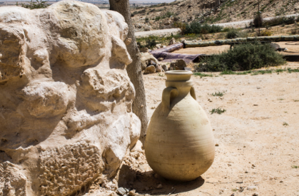
4 Returning …

SERVANTHOOD
CALL TO PRAYER
Trust in God at all times, people
Pour out your hearts to the Holy One
For God alone my soul waits in silence

Stillness
OUR THEME TODAY
Returning. A woman given living water returns, inspired, to her community.
Two Emmaus friends, bereaved hosts, return inspired with a resurrection story.
The hospitality of a drink, and of a meal gives rise to an unimagined astonishing future:
Returning to another chance at life.

God of compassion, Restorer of the dawn
We know of course, you and I, that morning will
After this prolonged night, return …
Brand your hope into the center of my heart …
So that if anyone should question me
About my hope in darkness
I’ll be ever ready to explain.
M Wiederkehr, Seasons of your Heart.

SCRIPTURE : John 4:28 – 30, 39 – 42 Acts 8:4-8, 14-17
Psalm 126. 4-6 Jonah 1.1-3; 3.1-5 Luke 17.11-19 Luke 24.13-35

REFLECTION
+ is there something that God is calling you to recollect and return to?

+ choose a returning figure (the Samaritan woman, the prodigal son, Emmaus friends, the apostles to Samaria, Jonah, the healed leper) and imagine their returning journey and the reception they got. Stay with this meditation, notice the context, the emotions, the words and actions of others, … and speak with the Holy One or Jesus or rest in God’s Spirit.
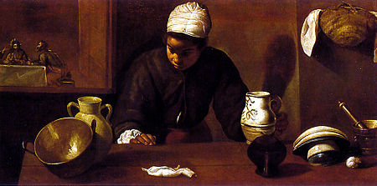
+ ponder Diego Velázquez (1599-1660) Kitchen Maid with the Supper at Emmaus

Silence - extended

Respond
+ ‘she left her water jar’; ‘they got up and returned at once to Jerusalem’ …
List for yourself tasks or roles or places that have been central to your life that you might nonchalantly abandon as you ‘return inspired’.

+ consider serving … how Ruth served Naomi, how Jesus asked a woman to serve him, how Philip, Peter, John served Samaria, Jonah serving Nineveh …. Share with others what servanthood might mean for you today, not in the future, but today.

PRAYER FOR OURSELVES, OTHERS AND OUR WORLD
We follow Jesus who came in humility ‘not to be served but to serve’, the path to true leadership. We empower the poor by placing control in their hands and not overpowering them with outside resources or expertise. With courage, we embrace sacrifice and suffering, and share faithfully in the life of Jesus and the poor. Servants’ principle: SERVANTHOOD

Jesus, our true leader, our servant-king, thank you for second chances, We pray especially today for those returning inspired …. for those returning to finish off tasks … for us all learning to serve, learning to suffer, learning to share … (silence)
(take turns reading alternate lines)
Strengthen those with weak hands
Make firm any feeble knees
Say to those of fearful heart:
Be strong, do not fear! Here is your God!

Then the eyes of the blind shall be opened
The ears of the deaf unblocked
The lame shall leap like a deer
And the tongue of the speechless sing for joy
For waters shall break forth in the wilderness and streams in the desert.

The redeemed of the Lord shall return
~ Banksy and come to Zion with singing;
everlasting joy shall be on their heads;
they shall receive gladness and joy,
and sorrow and sighing shall flee away.
(Isaiah 35)
SUNG BENEDICTION
May the peace of the Lord Christ go with you wherever he may send you
May he guide you through the wilderness, protect you through the storm
May he bring you home rejoicing at the wonders he has shown you
May he bring you home rejoicing once again within our doors.
- Northumbria Community.

5 Risking ….
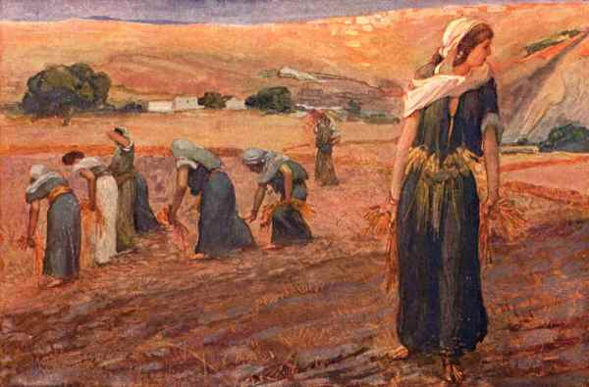

REST
CALL TO PRAYER

Trust in God at all times, people
Pour out your hearts to the Holy One
For God alone my soul waits in silence

Stillness
OUR THEME TODAY
Risking. A young widow, recklessly leaves her country and pledges herself to a long journey to a strange land; now, an immigrant, risking harassment, slips in behind harvesters, to gather some grain … and glimpses a second chance - to be settled, at home, at rest.
Holy God – in the stillness speak to me.
As you speak so may I listen.
As I listen so may I hear your voice.
As I hear your voice so may I respond to you in love and obedience.
Speak to me o Love Divine.

SCRIPTURE : Ruth 2
Genesis 2:15 -17 Isaiah 42.1-9 Luke 19:1-10 Luke 21:1-4
REFLECTION
Ruth is something of a Jesus-figure: her actions and choices throughout the story point to the way of Jesus. She, like him, leaves home; he too, comes alongside in our despair and bitterness; he too pledges faithfulness, treats us with kindness, humbly takes on a new identity, settles and finds a home in us; he too, takes risks among complete strangers to bring us a different future, lets things ‘turn out’, is vulnerable and responsive to us; he too, recklessly lies down with us, awaits our recognition and response, humbly and quietly hovers in the shadows, waits for our active engagement; Jesus, like Ruth, is the focus of joy and bringer of redemption, giving birth to new life.

Silence - extended
Respond
+ wander in a park, forest, desert, garden and notice how Nature takes risks and commits to rest; stop and contemplate an example of this for some time

+ financial risks intrigue us: contrast risk-taking by a transnational company and by a local street-vendor; compare Zacchaeus’ risks with the widow’s offering; how might I be ’at rest’ with money.

+ do something physically risky in your space e.g. a blind-folded task; falling backwards in a circle of supporting people…. followed by a period of rest.

+ ponder together the nature of Ruth’s rest .. ch 2: 7; 8-9; 12-13; 22-23.

+ pray together, alternating voices
Lord, you have always given bread for the coming day;
And though I am poor, today I believe.
Lord, you have always given strength for the coming day;
And though I am weak, today I believe.
Lord, you have always given peace for the coming day;
And though of anxious heart, today I believe.
Lord, you have always kept me safe in trials;
And now tried as I am, today I believe.
Lord, you have always marked the road for the coming day;
And though it may be hidden, today I believe.
Lord, you have always lightened this darkness of mine;
And though the night will come, today I believe.
Lord, you have always spoken when time was ripe;
And though you be silent now, today I believe.
Northumbria Community, Celtic Daily Prayer, Evening.

PRAYER FOR OURSELVES, OTHERS AND OUR WORLD
God calls us to regular rhythms of work, rest and reflection – weekly Sabbaths and regular holy-days (holidays). We seek to obey God’s command to rest in order to be refreshed, to be still and to deepen our relationship with God and one another. Servants’ value REST

In our world of frenetic striving,
we pray for restful rhythms
to frame the risks and grow trust in You –
and especially today we think of …

open prayer

SONG
Stay with me remain here with me
Watch and pray, watch and pray.
Taize: www.youtube.com/watch?v=LmAOcHqvS0Q

BENEDICTION

May you be filled with light
May the indwelling presence of Christ heal you
May your fears be changed into love
May you be a gift ready to be given.

6 Risking …
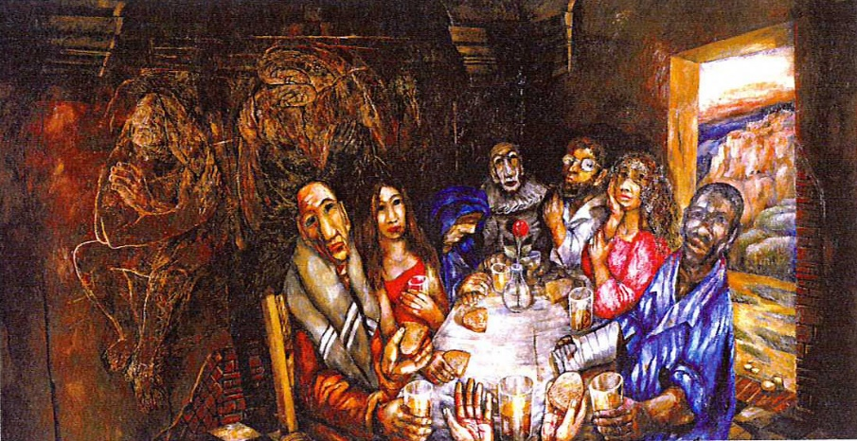

Sieger Koder
COMMUNITY
CALL TO PRAYER
Trust in God at all times, people
Pour out your hearts to the Holy One
For God alone my soul waits in silence

Stillness
OUR THEME TODAY
Risking. A man, paralyzed for 38 years, risking all that he knows, risking community, stands up and walks – a second chance at fullness of life.
Holy God – in the stillness speak to me.
As you speak so may I listen.
As I listen so may I hear your voice.
As I hear your voice so may I respond to you
in love and obedience.
Speak to me o Love Divine.

SCRIPTURE : John 5. 1 – 14;
Isaiah 54 Mark 2.1-12 Luke 7.1-10 Acts 2.42-47 Romans 8.14-25
REFLECTION

Consider in the quietness –
In what ways am I paralysed, stuck, blaming others, unable to move forward?
How do I answer Jesus’s question: Do you want to be made well? With excuses; with ‘yes, but …’ and without hope?

Perhaps my community feels victimised, at the mercy of others, unable to step into life-giving ways? How does my community answer Jesus’s question: with ‘It’s been like this for years. Nothing changes.’ Or ‘There’s no one to help us’ or with ‘We try but …’

Where are the outsiders who can give us courage? The Ruths from Moab, the women of Samaria, the Roman centurions …

Silence - extended

Respond
+ identify some courageous changes in lifestyle you may being invited to make – to stand up to businesses, governments, neighbourhoods, to take up your bed of apathy, and to walk towards change that brings life.

+ consider the image painted by Koder. Notice the colours, shadows, forms, texture. Invite the image to a place deep with you. Stay with what most ‘affects’ you. Let God visit you. Let your ‘real self’ make conversation with the ‘real God’.

+ ask the community of friends around you to challenge and support you as you seek healing and deliverance: (perhaps take turns being the four friends who bring another to Jesus for blessing, for forgiveness … Mark 2)

+ watch: Mike Hood “Reason” on www.youtube.com/watch?v=FvExOMJ8pYA- and share your thoughts on how risking & community might interweave.

PRAYER FOR OURSELVES, OTHERS AND OUR WORLD
As well as a commitment to the communities we move into, we have a passion to work together in supportive teams that model the love, care and community that Jesus spoke of. We work with people, not just for them. Servants’ principle COMMUNITY
We name communities we are part of and hold them in humility and love before God.
Silent prayer
Prayers of Penitence

Human sin disfigures the whole creation,
which groans with eager longing for God's redemption.
We confess our sin in penitence and faith.
We confess to you our lack of care for the world you have given us,
and our failure to protect the vulnerable ~Banksy
Lord, have mercy.

We confess to you our selfishness in not sharing the earth’s bounty fairly
and in not standing up for others.
Christ, have mercy.

We confess to you our desire to go it alone, to control those around us,
and our fear of intimacy and openness.
Lord, have mercy.

May the Mother and Father of us all, cleanse us from our sins,
and restore to us another chance at the glory of the power that is love;
AMEN. Derived from New Patterns for Worship p470-471

SONG Be still and know that I am God
I am the Lord that healeth thee
In thee O Lord do I put my trust
BENEDICTION
May you be filled with light
May the indwelling presence of Christ heal you
May your fears be changed into love
May you be a gift ready to be given.

****

7 Encounter ….
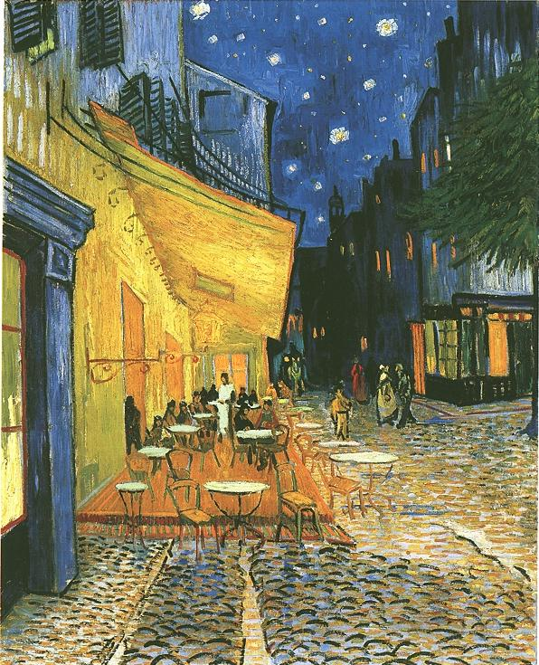

~Vincent van Gogh, The Café Terrace, Arles
GRACE
CALL TO PRAYER

Trust in God at all times, people
Pour out your hearts to the Holy One
For God alone my soul waits in silence

Stillness
OUR THEME TODAY

Encounter: threshing floor, grassy hillside; city roads; rocky cave; café table …
Intimacy is at hand. Grace is at hand. (It m ay even come disguised as ‘risky, unwise, misunderstood’.)

Holy One, Jesus, Pain-bearer, Life-giver, Lover of our souls
We long to encounter you.
We long for our world to encounter you
Your hospitality, delight, tenderness, abundance –
unearned, unwarranted, even unsought.
A look of love. A whisper of wellbeing.
A gesture of generosity. . . intimate and inclusive.
Dare we? Are you safe?
What if you see me in my darkness?
What if you ravish me … tenderly ?
Holy One, Lover of our souls

SCRIPTURE : Ruth 3
1 Kings 19.1-16 Songs 8.5-7 Mark 10:17-22 Mark 14:3-9 Romans 8.38-39

REFLECTION:
Linger with this account of a truly gentle man, carefully respecting a vulnerable woman and be grateful. Consider how God’s tender care of you is reflected in this story.

Silence - extended
Respond
+ Naomi, through Ruth’s courageous action, is looking for a second chance for her family. Consider where in your own life a second chance came along: what was your response – action or paralysis? Might you share the story in some way – by mime or sketch or poem?

+ How do you care, or have you cared, for a vulnerable person? Perhaps, like most of us, you also can recall when you have trampled on another’s fragile self. Talk to the God who is Love about the feelings that surface.

+ Imagine yourself entering the scene depicted by van Gogh. Take time and let events and conversation unfold as you encounter the Christ.

+ Recall an encounter of the powerless and powerful (Rosa Parkes, Telemachus …) and how that brought change, new insights, new life.

PRAYER FOR OURSELVES, OTHERS AND OUR WORLD
All that we do and are is rooted and sustained by God’s lavish, unearned love, favour and forgiveness towards us. This profound grace delivers us from unhealthy striving, competition and condemnation of ourselves or judgment of others. Servants value GRACE
~ Banksy
Holy One – Earth-maker, Pain-bearer, Life-giver,
We are so grateful that because of Jesus we now understand you as love, beauty, joy, patience . . we need not now be fearful of punishment, of harsh judgement;

Thank you, Holy One, that we now can look at our world and our lives,
from the perspective of a God who loves,
as a creative artist, a comforting companion, a peacemaker,
alongside an understanding of a God who is just,
a champion of the oppressed, a burner of harvest stubble
a judge of hypocrisy.

God of second chances, as we bring to mind the week that has passed,
the world we inhabit, the inklings of the future ahead,
give us your perspective, your look of love;

We invite you to make your disappointments our disappointments,
to make your anger our anger,
to make your pain our pain,
to make your hope our hope.

In the silence, in our hearts, let us look on our world,
let us look on our week, as God does, with love … and whisper our prayers.

Open prayer

SONG
Jesus, be the center; be my source, be my light, Jesus
Jesus, be the center; be my hope, be my song, Jesus
Be the fire in my heart; be the wind in these sails; be reason that I live, Jesus.
Jesus be my vision, be my path, be my guide, Jesus.
- www.youtube.com/watch?v=TqCMTkSqv4I
BENEDICTION
May the gentleness and strength of God
The delight and vulnerability of the way of Christ
And the graceful mystery of the Holy Spirit
Be with you now and always. AMEN
8 Encounter …
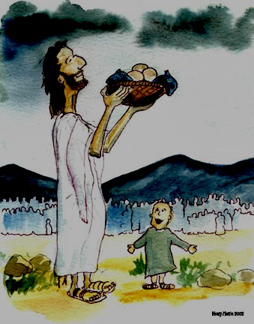

CREATIVITY

CALL TO PRAYER

Trust in God at all times, people
Pour out your hearts to the Holy One
For God alone my soul waits in silence

Stillness

OUR THEME TODAY

Encounter. Threshing floor, or grassy hillside; city roads or café table;
rocky cave solitude or in the midst of a crowd.
What turns a chance meeting into a life-giving encounter?

Holy One, Jesus, Pain-bearer, Life-giver, Lover of our souls
We long to encounter you.
We long for our world to encounter you
Your hospitality, delight, tenderness, abundance –
unearned, unwarranted, even unsought.
A look of love. A whisper of wellbeing.
A gesture of generosity. . . intimate and inclusive.
Dare we? Are you safe? What if you see me in the crowd?
And if you look on me with love? What if …?

SCRIPTURE : John 6.1 - 14

Deut. 8.1-9 Ezekiel 47.1-12 Luke 13.18-21 John 6.32-40 Acts 3.1-10 Rev 22.1-7
REFLECTION
Use lectio divina (read, reflect, respond, rest) or Gospel contemplation (as follows) -
..Imagine: You are on the hillside amongst the large crowd - what would you hear? what would you see? what would you smell? What’s happening? what is in the background? what is the emotional atmosphere like?
..Enter into the story: without forcing anything, what are you drawn to in the story? Perhaps you particularly identify with one of the characters, or a bystander…
..Allow the story to unfold: notice how you find yourself responding – your thoughts, actions and feelings, maybe let things unfolds a little differently to the biblical account. Do you find yourself interacting with Jesus? Is there anything you want to say to him, or ask him? Is there anything he seems to want to say to you … what happens next? Take your time…
..Reflect: Sit with the encounter and its significance. It might be helpful to journal your reflections. Allow this to lead into prayer, as seems appropriate.

Silence – extended

Respond
+ name the crowds you interact with – is that stressful or relaxed? How would you answer Jesus’ question to you: where are we to get food for these people?
+ form (12) small groups and invite each to be creative with 5 leaves and 2 flowers or pebbles, and a candle. And to place their creation on a centrepiece (12 baskets left over)
+ set aside time and energy in the next few days to bless others with your creativity: bake a cake, plant some seeds, write an intercessory prayer for your faith community to use, tell a story to those kids …

PRAYER FOR OURSELVES, OTHERS AND OUR WORLD
By allowing our senses, our imaginations, our minds and bodies to fulfil their God-given potentials for creativity, we glorify God. We believe it does our souls good (and pleases God) when we create, through writing and storytelling, poetry, cooking, music, painting and other art forms.
Servants’ value CREATIVITY

Where resources seem scarce and spaces seem tight
in our families, our neighbourhoods, our world,
we pray for your abundance and creativity to flow …
and especially today:

Open Prayer

Pray together
Eternal Spirit, Earth-maker, Pain-bearer, Life-giver,
Source of all that is and shall be,
Mother and Father of us all.
Loving God in whom is heaven –
~ Banksy
The hallowing of your name echo through the universe
The way of your justice be followed by all peoples on Earth,
Your heavenly will be done by all created beings
Your commonwealth of peace and freedom sustain our hope and come on Earth.

With the bread we need for today, feed us;
In the hurts we absorb from one another, forgive us;
In the times of temptation and test, spare us;
From the grip of all that is evil, free us.
For you reign in the glory of the power that is Love, now and for ever. AMEN
NZ Aotearoa Prayer Book

SONG Jesus, be the center; be my source, be my light, Jesus
Jesus, be the center; be my hope, be my song, Jesus
Be the fire in my heart; be the wind in these sails; be reason that I live, Jesus.
Jesus be my vision, be my path, be my guide, Jesus.
- www.youtube.com/watch?v=TqCMTkSqv4I
BENEDICTION
May the gentleness and strength of God
The delight and vulnerability of the way of Christ
And the graceful mystery of the Holy Spirit
Be with you now and always. AMEN
9 Redeeming ….
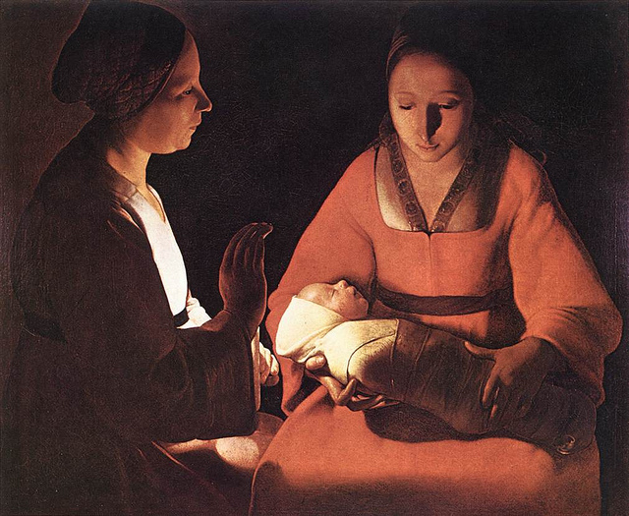

"Newborn". Georges La Tour (1593-1652)
INCARNATION
CALL TO PRAYER
Trust in God at all times, people
Pour out your hearts to the Holy One
For God alone my soul waits in silence

Stillness
OUR THEME TODAY
Redeeming a family: Ruth’s commitment gives birth to a future.
Redeeming our world: Mary’s availability gives birth to God-with-us
Eternal and Wise God
Whose nature is to bring forth
Abundant fruit from desert places, salvation out of failure:
Continue to look with mercy upon your creation,
That we whose semi-arid lives give little space for your Spirit to grow,
May awaken to your redeeming work of compassion,
Rejoicing that a desert can bloom.
Amen. -Terry Garley, Lancashire, England.

SCRIPTURE : Ruth 4 Matt. 1:1-17
Zechariah 9: 9-12,16-17 Isaiah 9:2 -7 2 Timothy 1:3-7 John 1:26-29 Rev 7:9-17
REFLECTION
Boaz gently offers hospitality of heart and hearth to Ruth. He persists through the legalities to redeem her difficult situation: the famine, the migration, the grief, the bitterness, the risks of harvest time, the daring plan, the confusing kinsmen - now all behind them. Hope restored. A second chance at life.

The genealogy of Jesus similarly is startling evidence of God’s gentle persistence in overwhelming, with good, the chaotic actions of humankind: Judah visited prostitutes, Rahab deceived by covering up her night visitors; David has an affair and murdered; Solomon flirted with other spirits – all to arrive at Joseph, the right man as a husband to provide a tender and safe place for Mary to be able to welcome and surrender her body to God. (Mary’s own forbears seem irrelevant – good on her!)
Hope restored. A second chance for humankind.

Silence - extended
God of surprises, sandals and second chances:
Redeeming is something quite rare today -
“not redeemable for cash” says the small print on my book voucher -
And a kinsman-redeemer even rarer.
The patriarchy in Boaz’s Bethlehem sits uncomfortably.
O God of second chances, have mercy.

We are not worthy to even untie your sandal straps,
So you take off your sandals for us.
You even take off your t-shirt,
tie a towel around, and wash our feet.
The humanity in Jesus’ Bethany sits uncomfortably.
O God of second chances, have mercy.

Redemption – exchanging a card for something useful
Exchanging Naomi’s emptiness for a new life
A second chance surprise from a generous daughter-in-law.
A fading genealogy redeemed …. and gives rise to:

Incarnation –an unknown God becomes Someone Grace-full
Human conception becomes something divine
A second chance surprise from a generous Lover
Inclusion in God’s future sits uncomfortably
O God of second chances, have mercy.

~ Banksy

Respond
+ gaze a while at Georges La Tour’s “Newborn”, waiting for the Holy One to call your attention to one of the relationships. What might be being born anew for you?

+ make a collage to express redemption and incarnation – gather magazines, newspapers, flyers arriving in letterbox, a collage of digital images & words
+ share stories of incarnation e.g. The Beggar by Mike Hood, /www.youtube.com/watch?v=XFfiRXTWNvM

+ read Isaiah 29.17-24 listening for a word or phrase that touches you, that connects with your longings, that invites you to redemption, restoration, a second chance.

PRAYER FOR OURSELVES, OTHERS AND OUR WORLD
We intentionally live with the urban poor, learning from them, building genuine relationships, participating in their lives and struggles, learning their language and their culture, and working out how Jesus’ love can best be shown in their context. Servants’ principle INCARNATION

You are invited to use and adapt St Patrick’s Breastplate as you pray for our world …

Christ be with me, Christ within me,
Christ behind me, Christ before me,
Christ beneath me, Christ above me,
Christ beside me, Christ to win me,
Christ in quiet, Christ in danger,
Christ in hearts of all who love me,
Christ in mouth of friend and stranger.

SONG O Lord hear my prayer, O Lord hear my prayer,
When I call answer me // Come and listen to me. (Taize)

BENEDICTION

May the Creator give you weavers’ hands
that we may mend the torn fabric of life.
May the Saviour give you the eye of an eagle
That we may see far and deep.
May the Spirit give you rhythm in your frame
That we may dance wholesomeness to uneasy communities.
May the Three-who-are-One give you a hospitable heart
That we may draw others to warm themselves
May these human and holy Ones be in you
And fire us to join the endless adventure.

10 Redeeming …

~ Banksy
CELEBRATION

CALL TO PRAYER

Trust in God at all times, people
Pour out your hearts to the Holy One
For God alone my soul waits in silence

Stillness

OUR THEME TODAY
Redeeming a wedding party: Jesus gives celebrating a second chance!
Redeeming our planet earth: the Creator so loves the world - do we have a second chance?

Eternal and Wise God
Whose nature is to bring forth
Abundant fruit from desert places, salvation out of failure:
Continue to look with mercy upon your creation,
That we whose semi-arid lives give little space for your Spirit to grow,
May awaken to your redeeming work of compassion,
Rejoicing that a desert can bloom.
Amen. -Terry Garley, Lancashire, England.

SCRIPTURE : John 2.1-11

Exodus 15.1-21 Isaiah 58.9-14 Luke 15.1-8,32 Philippians 2.5-8 Rev 21.1-4

REFLECTION
Mary, Jesus’ mother: she notices a problem in the community, that the situation is deteriorating; she alerts Jesus, clearly and simply; Jesus tells her to wait, don’t worry; Mary, restless, reminds folk to obey if Jesus speaks to them; and before long, all are very surprised.
In short: notice what is running out – tell Jesus about it – wait till the time is right – obey, do what Jesus tells you – be amazed !
Respond
+ sketch six water jars and label each with what is running out in your life; or with what is very scarce in the group. Consider following Mary’s lead, prayerfully, waiting … what act of obedience might Jesus ask of you to redeem the situation? Watch with expectancy!

+ sketch six water jars and label each with what is abundant in our world; what is there plenty of? What are we doing with this extravagance? What do you envisage Jesus doing as you cooperate with him? Consider … watch …. wait … obey … is redemption needed here too?

+ celebrate a simple shared meal – taking care to use resources wisely: home-made bread or muffins; hand-squeezed orange juice or local wine. Appreciate the action of yeast and raising agents and kneading and mixing and squeezing … and waiting … and gathering together, and sharing and giving and receiving … and enjoying, dancing.

PRAYER FOR OURSELVES, OTHERS AND OUR WORLD
Directing our celebrations to God in worship, we look for excuses to throw parties, consciously marking every milestone and achievement – no matter how small! We want to be people of generosity, who refuse to take ourselves too seriously. Servants’ value: CELEBRATION

O God who celebrates and delights over us with joy, today we especially want to celebrate and bless ….
As situations and people are named, let’s respond appropriately!

Pray together:
Lord God,
Do for our world as you did in Cana of Galilee:
Take our old water, our ordinary everyday lives,
And turn them into gospel wine.
Hear our prayer, and call us to celebrate with you:

May our worship honour your generous gifts; may we explore together our responsibilities to the creation of which we are a part, in preaching and teaching, in prayer and praise:
for the earth is yours and all that is in it.

May our buildings, our homes, be places of prayer, and signs of the renewing power of your grace to sustain and refresh all life;
may our use of the resources we have inherited be an example of care and generosity;
for the earth is yours and all that is in it.

May we allow the land we occupy to flourish in your care; may we share and protect open space and managed earth, and build community with and through the land and all it sustains:
for the earth is yours and all that is in it.

May we live as the body of Christ, fostering relationships within our local and global communities, and raising awareness of how our actions affect our sisters and brothers across the world, having a particular care for the poorest and most vulnerable:
for the earth is yours and all that is in it.

May we show in our lives what we claim in our words, revealing in our actions our love for you, for each other, and for your world, following your invitation to bear fruit that will last:
for the earth is yours and all that is in it.

Lord God, Do for our world as you did in Cana of Galilee:
Take our old water, our everyday ordinary lives,
And turn them into gospel wine.
Hear our prayer, and call us to celebrate with you. Amen.

SONG
Bless the Lord my soul and bless God’s holy name Taize
OR
Ceili Rain - www.youtube.com/watch?v=equHWxmRjac

BENEDICTION
May the Creator give you weavers’ hands
That we may mend the torn fabric of life.
May the Saviour give you the eye of an eagle
That we may see far and deep.
May the Spirit give you rhythm in your frame
That we may dance wholesomeness to uneasy communities.
May the Three-who-are-One give you a hospitable heart
That we may draw others to warm themselves
May these human and holy Ones be in you
And fire us to join the endless adventure.

Ceili Rain
There’s nothing behind me, there’s nothing ahead
There’s only this vision of You and to it I’m led
I’ve gathered around me folks that feel like I do
And our only passion is to celebrate You
We gather together, tears of joy in our eyes
Intoxicated, just standing under Your skies

We’re making a party, we’re feeling no pain
We’re drunk on the love that pours from above in Your precious name
Oh this is some party, in it there’s no shame /and You are to blame!
We’re just high on the heavenly home / hope this glorious ceili rain

Pater noster qui est in coeli Our Father, our way,
We cherish these words that Your Son once gave us to pray
Et Spiritus Sanctus we answer the call.
To this downpour of heavenly heartiness you give us all
So strike up the fiddle and bang on them drums
We celebrate life in You from whom it all comes.

Well, this is some party, we don’t have to be scared
That we’re not hip and groovy, see, cos here nobody cares
So here we’re all sinners, all just like myself
We’re too busy praying for judging anyone else.
Fill up our glasses, full with Your grace
Lift up our voices, we lift them in praise.

