.One Stillness in the turmoil :: trust at midnight
Awaken me to your presence
Alert me to your love,
Affirm me in your peace.

Open to me your way
Reveal to me your joy,
Enfold me in your warmth.

For my heart is ready,
Holy One, my heart is ready.
…

As I enter into prayer today, I am settled and still.
I attend to my breathing and speak to God:
Holy (in-breath) One (out-breath), Holy … One …. Holy …One …
I gently surrender any distracting thoughts.

…. Silence ….

From Psalm 107
Some went down to the sea in ships, doing business on the mighty waters;
²⁴ they saw the deeds of the Lord, his wondrous works in the deep.
²⁵ For he commanded and raised the stormy wind, which lifted up the waves of the sea.
²⁶ They mounted up to heaven, they went down to the depths;
their courage melted away in their calamity;
²⁷ they reeled and staggered like drunkards, and were at their wits’ end.
²⁸ Then they cried to the Lord in their trouble,
and he brought them out from their distress;
²⁹ he made the storm be still,
and the waves of the sea were hushed.
³⁰ Then they were glad because they had quiet,
and he brought them to their desired haven.
³¹ Let them thank the Lord for his steadfast love,
for his wonderful works to humankind.
³² Let them extol him in the congregation of the people,
and praise him in the assembly of the elders.
an issue for nations:
what storms does a nation fear?
storms of violence and abuse; a storm of political voices; storms of migrants, of other religions, and ideologies; storms from global warming … a world out of control.
how does my nation handle its fear?

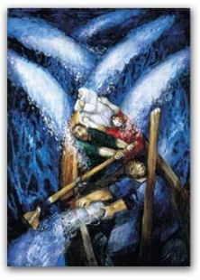
at midnight :: Mark 4.35-41
The sacred gaze:

With the image before you, allow yourself to be drawn into the picture; open yourself to the characters, the event.
Do not think … analyse … or read the Bible passage - just gaze.
See the colours, lines, forms and possible texture. Watch the movement, the stillness, the opposites, the contrasts.
Commit the image to memory, learn it ‘off by heart’ – as it were. Whenever your attention strays, quietly return to the image.

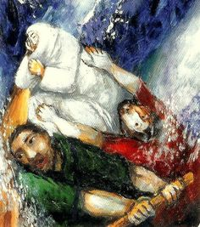
Perhaps you are being invited to position yourself somewhere in the scene depicted. Stay with what most ‘affects’ you or invites you. Let it deeply enter your awareness.

What Jesus said
Let’s go over to the other side …
Quiet! Be still!
Why are you so afraid?
Where is your trust?

What might it mean for him to say these words to me today …… right now in my life?
What might the other side be?
…
What might it mean for Jesus to speak these words to this nation …. In today’s storm? Dare I consider going over to the other side to see that perspective?

Let your ‘real self’ have a conversation with the ‘real God’.

Gently withdraw from the image. Notice your breath flow through you – and relax.
Consciously step out of this experience and choose a reflection that is helpful.
Reflection:
Where – perhaps – in this image has God visited me? How – perhaps – has the image helped me to hold before God some aspect of the self that is me? What has begun to be known? What has become visible? What do I need to revisit?
What is stirring in me as I pray? Am I consoled, troubled, left cold? I imagine Jesus himself standing or sitting at my side, and share my feelings with him.

…

Response
You may wish to linger a while with parts of this meditation. Notice where the energy was strong – and return there.
Write a letter to God . . . or to the newspaper . . . or on Facebook . . . or sketch a cartoon, and share your insights with someone you trust.
A Leunig prayer
God, give us rain when we expect sun.
Give us music when we expect trouble.
Give us tears when we expect breakfast.
Give us dreams when we expect a storm.
Give us a stray dog when we expect congratulations. God, play with us, turn us sideways and around. AMEN

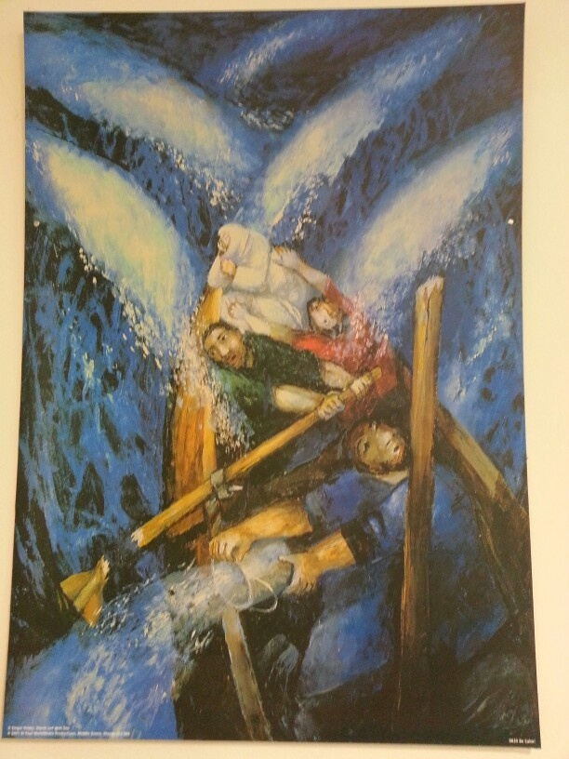
Rest
Be still in the presence of the One who loves you. Do not worry that you may appear to be doing ‘nothing’. Trust that the Holy Spirit is at work in the depths of your spirit… deepening your faith while the storms rage.
Let the image and its message move from your head to your heart to dwell there in peace-full silence.

May the gentleness and strength of the Holy One
The delight and vulnerability of thy Way of Christ
And the graceful mystery of the life-giving Spirit
Be with you now and always. AMEN

